Potential Questions for The Fuels Unit

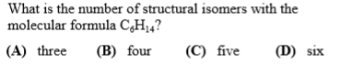

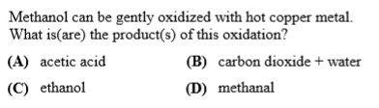

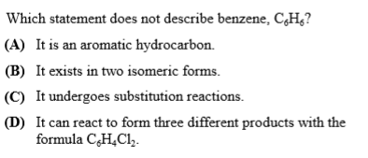
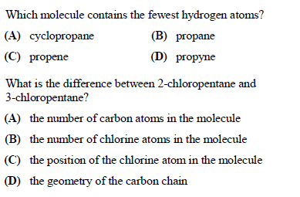

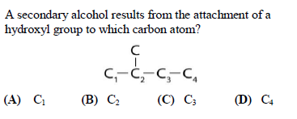
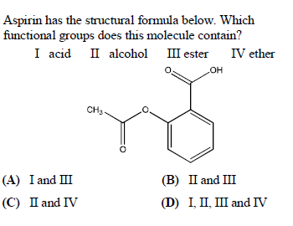
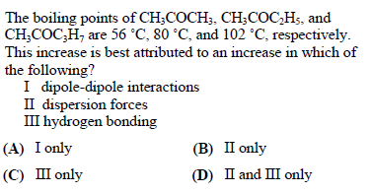

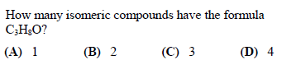

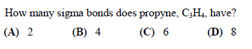
One of the major problems with use of ethanol as an engine fuel is
‘ (A) Water solubility.
(B) Increase of octane number.
(C) Decrease of octane number.
(C) Availability of ethanol.
(D) Toxic emissions.

Which of the following molecules is considered the “gold standard” for determining the octane rating of a fuel?
(A) n-heptane
(B) n-octane
(C) tetraethyl lead
(D) 2,2,4-trimethylpentane
(E) methyl tertiary-butyl ether (MTBE)

The octane rating of a fuel is most closely related to its:

(A) limiting of toxic emissions
(B) resistance to vapor lock
(C) anti-knock properties
(D) energy of combustion
(E) fuel/air stoichiometric ratio

Most gasoline-powered automobiles contain engines that are:
(A) 2-stroke
(B) 4-stroke
(C) 6-stoke
(D) 8-stroke

If an engine is “running lean,” it would likely have
(A) a low oxygen/fuel ratio
(B) poor gas mileage
(C) less power
(D) a higher temperature
(E) incomplete combustion

